## For 128 bytes data:

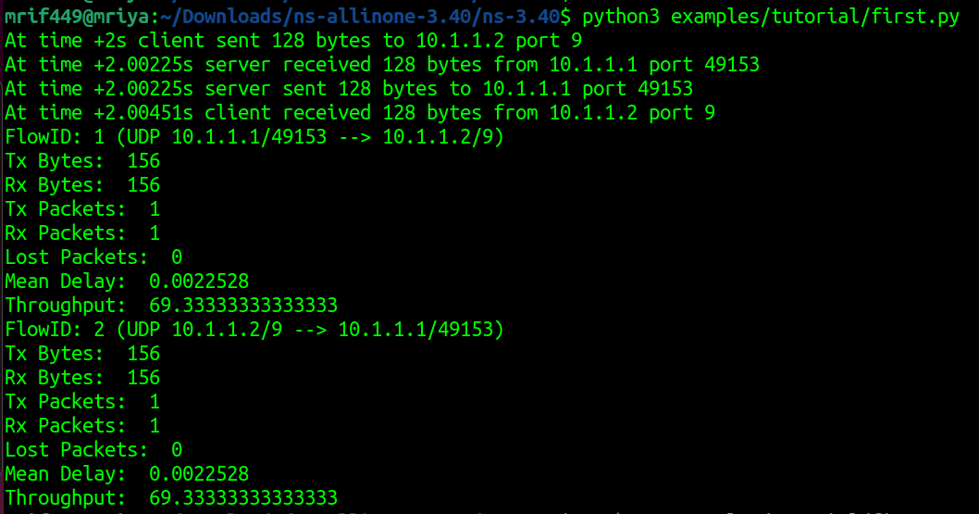

## For 256 bytes data:

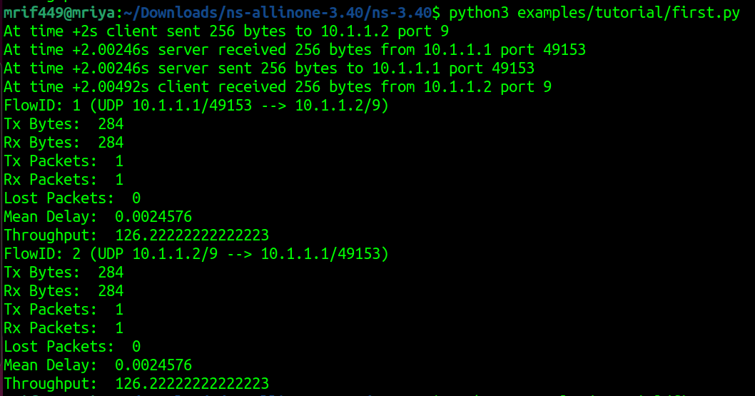

## For 512 bytes data:

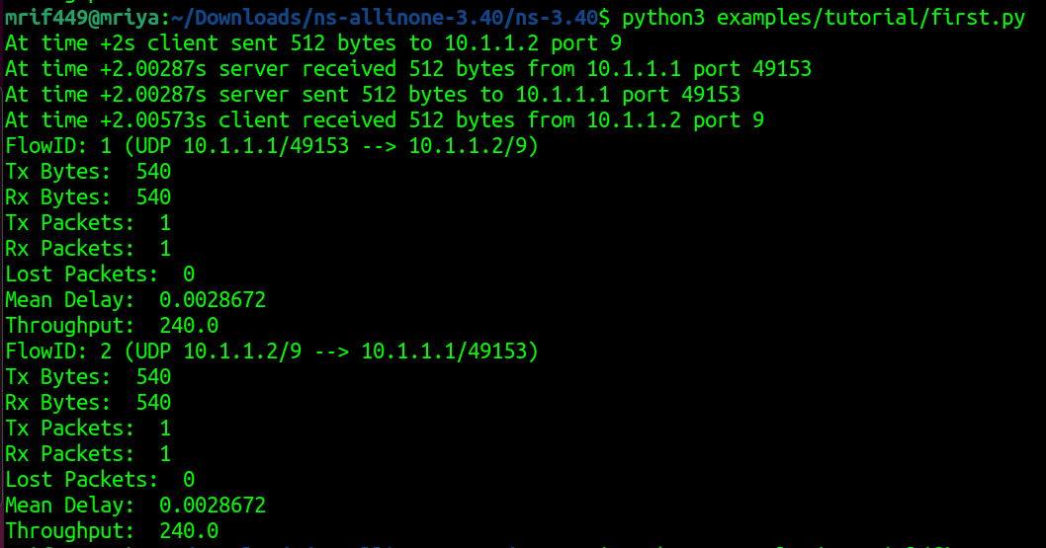

## For 1024 bytes data:

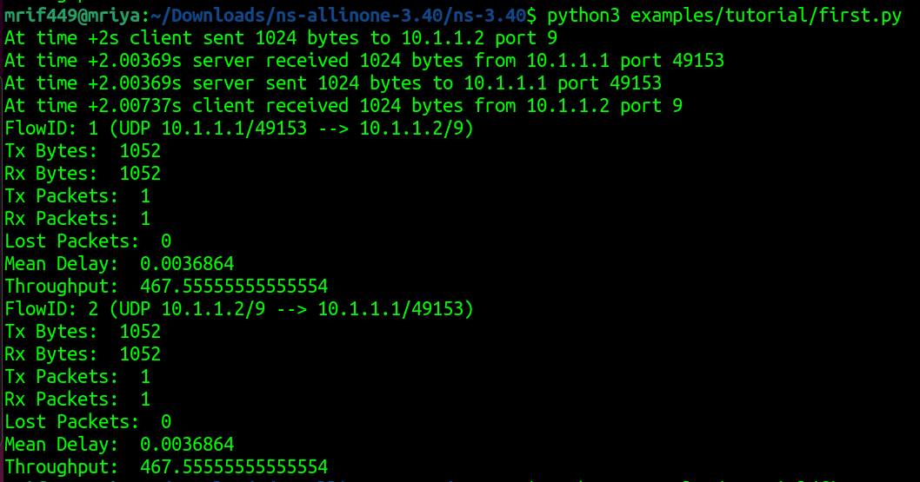

## For 2048 bytes data:

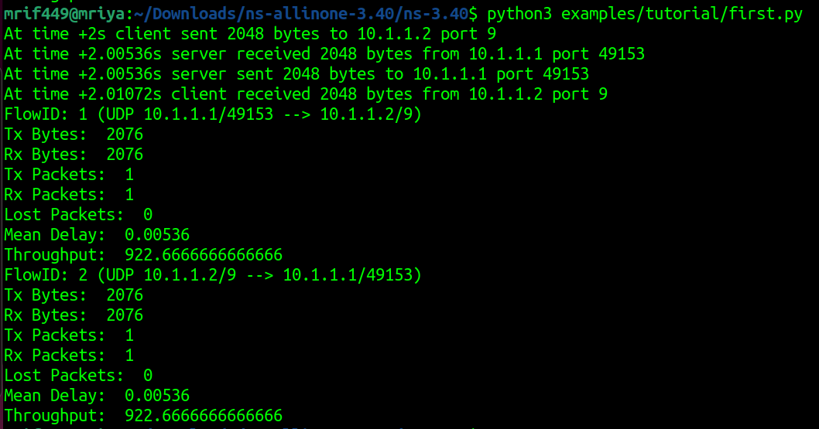

## Throughput Vs Data Size Graph:

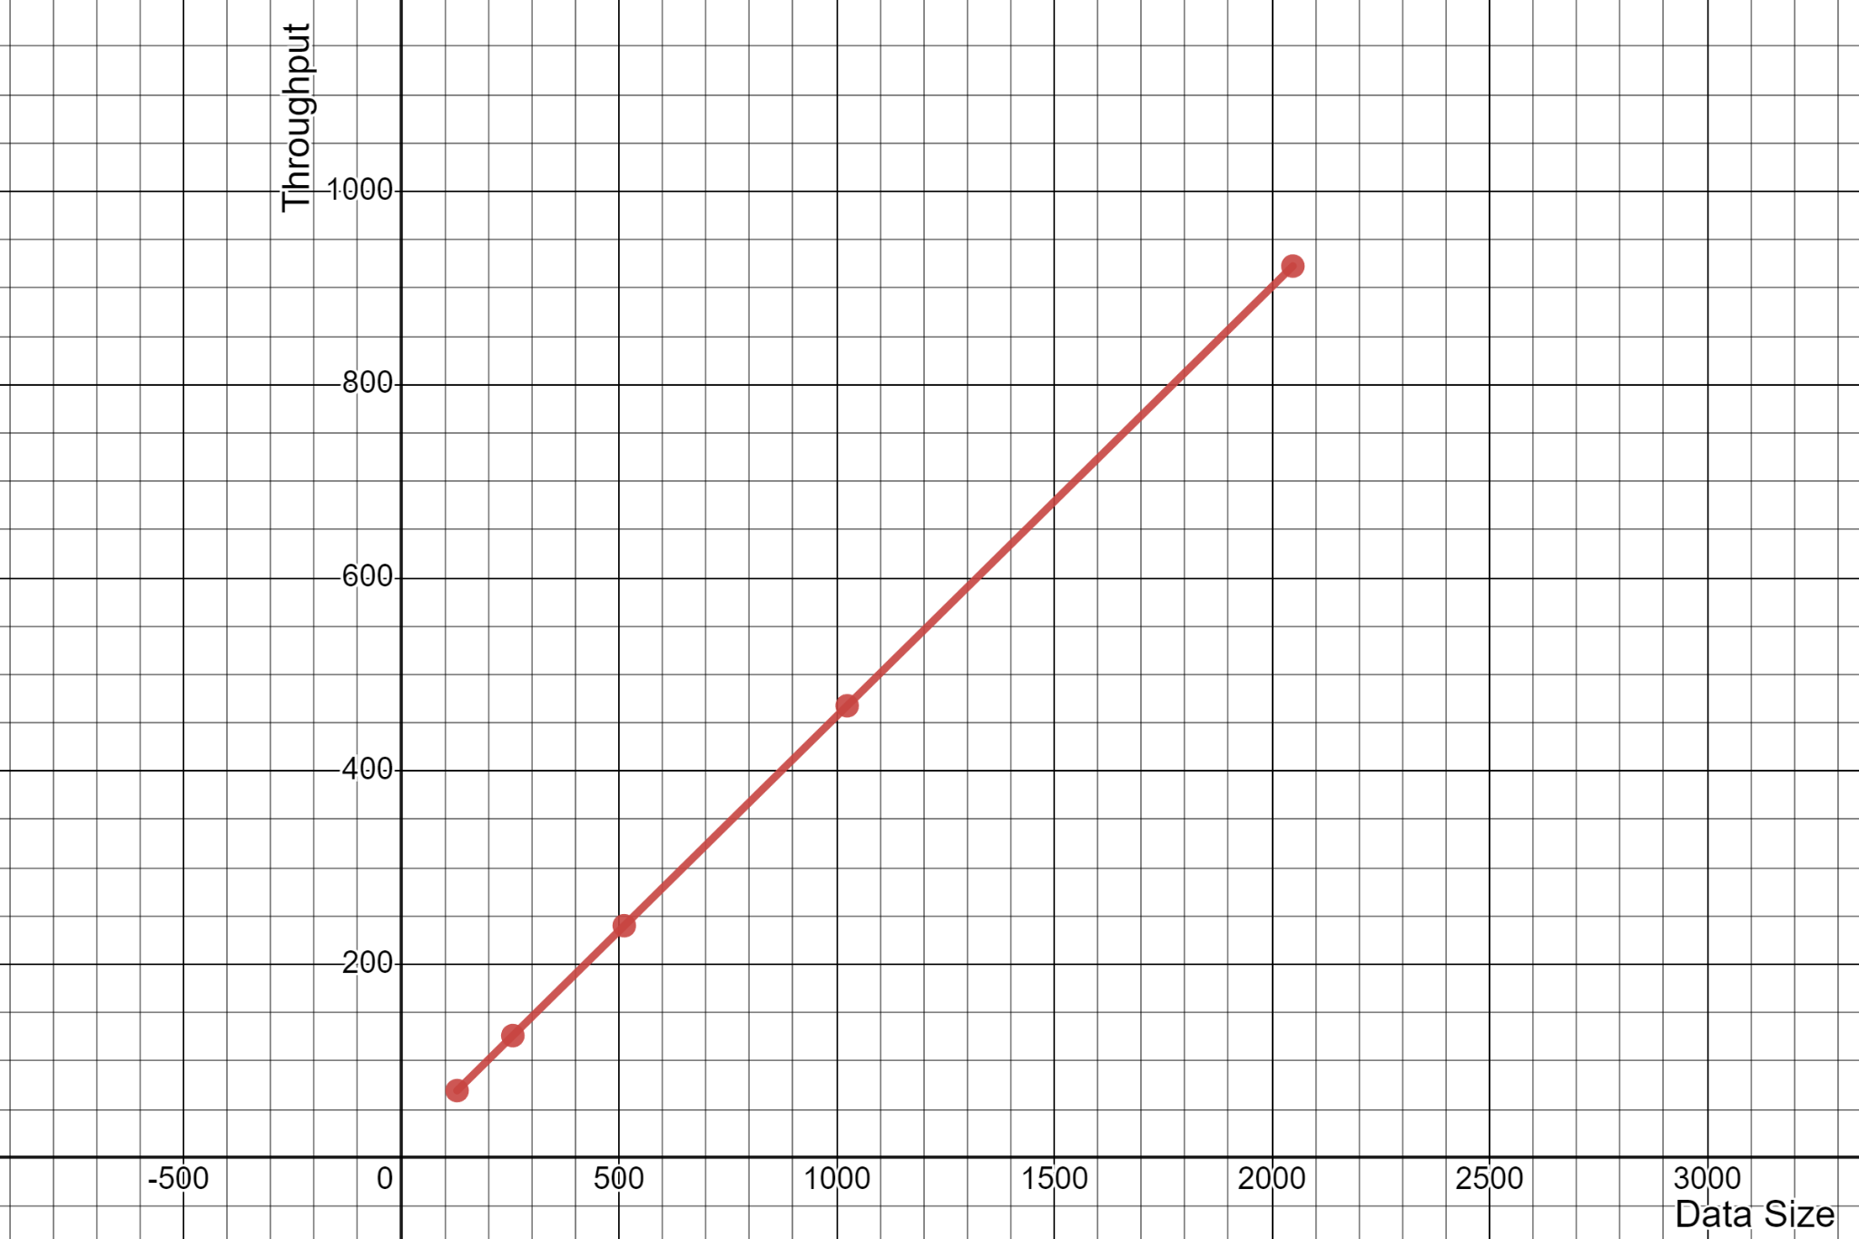

The graph shows a linear relationship between data size and throughput. This means that as the data grows, the throughput also grows at the same rate. The graph has points that represent the data size (x axis) and the corresponding throughput (y axis). The data size goes up gradually while the throughput stays constant and does not go down. This suggests that the process or system depicted can scale out and maintain efficiency.